**Round 2 Phase 3 – Working Prototype**

Title: Stats Paper

Team: KIIT_BHUBANESWAR_Glitch

Solution Design and Architecture

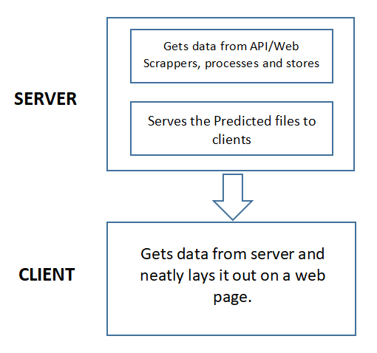

Fig: Solution Design

The news as well as the stock market data is provided by APIs and web scrapers. The server extracts the data downloaded and saves all predictions in json files for each stock index/price along with 5 news headlines and their predictions. The server does not save the info it gets from the API.

The predictions for stocks are made with current open, high and low prices. Forecast of open, high is made using machine learning regression models. For sentiment intensity classification, we use a svc machine learning model trained on a huge dataset with a custom dictionary to predict the sentiment of the news headlines.

On the user side, the webpage serves all the predictions to users with neat graphs and visuals. The javascripts extract info from the server periodically. The user can enter the company of their choice and see the current predictions.